DECISION TREE

AIM: To implement a python program for Decision Tree.

OBJECTIVES:
- To understand the basic concept of a Decision Tree.
- To classify data based on input features.
- To train a simple Decision Tree model.
- To predict the class of new data.
- To understand how decision rules are formed.
ALGORITHM:
- Import the Decision Tree classifier.
- Create a small training dataset with features and class labels.
- Create a Decision Tree model.
- Train the model using the training data.
- Get input values for a new sample.
- Use the trained model to predict its class.
- Display the predicted result.
SYSTEM-ARCHITECTURE:
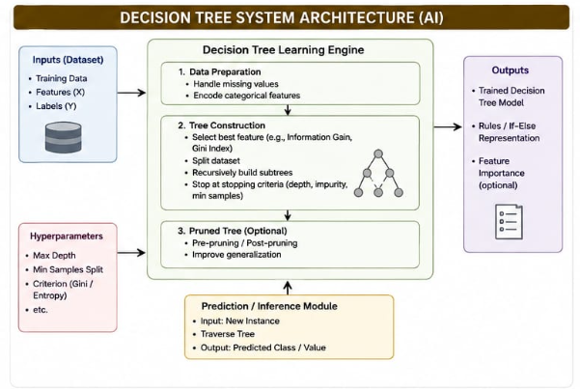

PROGRAM:
# Simple Decision Tree

def decision_tree(hours, attendance):
if hours >= 5:
if attendance >= 70:
return "Pass"
else:
return "Fail"
else:
return "Fail"

hours = int(input("Enter study hours: "))
attendance = int(input("Enter attendance: "))

result = decision_tree(hours, attendance)
print("Predicted Result:", result)

OUTPUT:
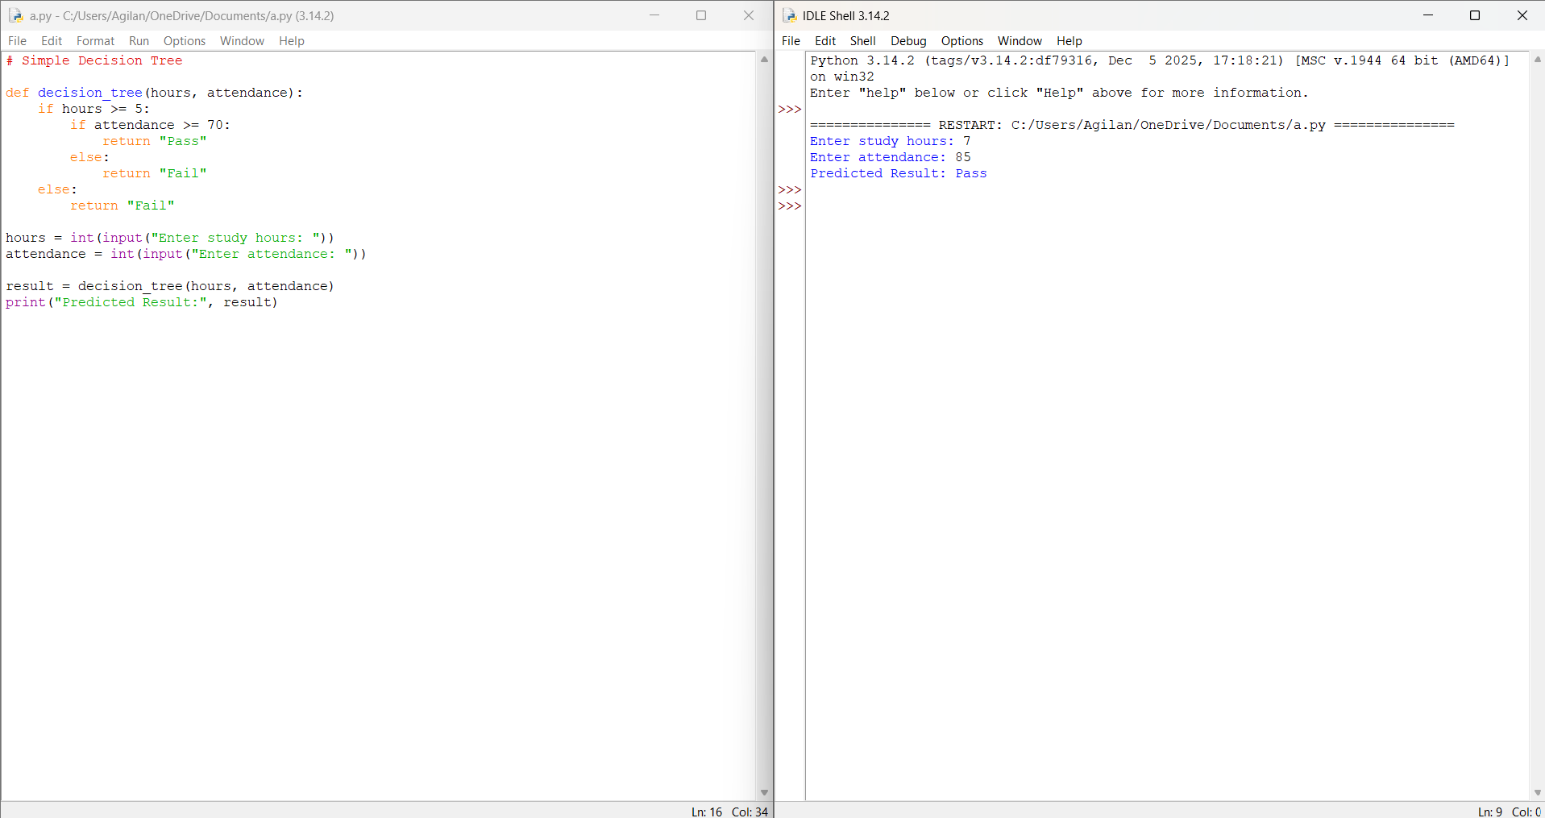

RESULT: Thus the Decision Tree is implemented successfully using python language.

